

**Government Engineering College**

**Sec-28 Gandhinagar**

**Sem: - VII**

**Subject: - Information Security**

**Subject Code: - 3170720**

** Government Engineering College**

**Sec-28 Gandhinagar**

**Certificate**

**This is to certify that**



*Mr./Ms. ………..***Italiya Nirajkumar Vijaybhai***……………….. Of class*

*……CE…… Division …A……, Enrollment No. …190130107041.. Has*

*Satisfactorily completed his/her term work in…* **Information Security**

*………. Subject for the term ending* *in ……………2022.*

*Date: -*

**Vision and Mission**

**Institute (GECG)**:

|  |  |
| --- | --- |
| Vision: | To be a premier engineering institution, imparting quality education for innovative solutions relevant to society and environment. |
| Mission: | * To develop human potential to its fullest extent so that intellectual and innovative engineers can emerge in a wide range of professions. * To advance knowledge and educate students in engineering and other areas of scholarship that will best serve the nation and the world in future. * To produce quality engineers, entrepreneurs and leaders to meet the present and future needs of society as well as the environment. |

**Department (CE):**

|  |  |
| --- | --- |
| Vision: | To achieve excellence for providing value based education in Computer Engineering through innovation, teamwork and ethical practices. |
| Mission: | * To produce computer science and engineering graduates according to the needs of industry, government, society and scientific community. * To develop partnership with industries, government agencies and R and D Organizations * To motivate students/graduates to be entrepreneurs. * To motivate students to participate in reputed conferences, workshops, symposiums, seminars and related technical activities |

**Course Outcomes:**

|  |  |  |
| --- | --- | --- |
| **Sr. No.** | **CO statement** | **Marks % weightage** |
| CO-1 | Explore the basic principles of the symmetric cryptography and techniques with their strengths and weaknesses from perspective of cryptanalysis | 10 |
| CO-2 | Implement and analyze various symmetric key cryptography algorithms and their application in different context. | 25 |
| CO-3 | Compare public key cryptography with private key cryptography and Implement various asymmetric key cryptography algorithms. | 25 |
| CO-4 | Explore the concept of hashing and implement various hashing algorithms for message integrity. | 20 |
| CO-5 | Explore and use the techniques and standards of digital signature, key management and authentication. | 20 |

|  |  |  |  |  |
| --- | --- | --- | --- | --- |
| **Sr.No.** | **Practical** | **Date** | **Page No.** | **Sign** |
| 1 | Implement Encryption-Decryption for Caesar cipher and brute force attack on Caesar cipher. |  |  |  |
| 2 | Implement Rail-fence cipher encryption-decryption. |  |  |  |
| 3 | Implement Playfair cipher encryption-decryption. |  |  |  |
| 4 | Implement key generation of DES. |  |  |  |
| 5 | Implement DES (Data Encryption Standard).**5** |Page |  |  |  |
| 6 | Implement key generation of AES. |  |  |  |
| 7 | Implement Diffie-Hellmen Key exchange Method.**5** |Page |  |  |  |
| 8 | Implement RSA key setup and encryption-decryption algorithm. |  |  |  |
| 9 | Write a program to generate SHA-1 hash. |  |  |  |
| 10 | Implement a digital signature algorithm. |  |  |  |

**Index**

**Practical-1:** Implement Encryption-Decryption for Caesar cipher and brute force attack on Caesar cipher.

**Code:**

#include<stdio.h>

#include<string.h>

#include<time.h>

int main()

{

char message[100], ch;

time_t t; // not a primitive datatype

time(&t);

int i, key;

printf("190130107041\n");

printf("Niraj Italiya\n");

printf("Prac 1-A\n");

printf("Implement Encryption-Decryption for Caesar cipher\n");

printf("%s\n\n", ctime(&t));

printf("Enter a message to encrypt: ");

gets(message);

printf("Enter key: ");

scanf("%d", &key);

for(i = 0; message[i] != '\0'; ++i)

{

ch = message[i];

if(ch >= 'a' && ch <= 'z')

{

ch = ch + key;

if(ch > 'z')

{

ch = ch - 'z' + 'a' - 1;

}

message[i] = ch;

}

else if(ch >= 'A' && ch <= 'Z')

{

ch = ch + key;

if(ch > 'Z')

{

ch = ch - 'Z' + 'A' - 1;

}

message[i] = ch;

}

}

printf("Encrypted message: %s", message);

return 0;

}

**Decryption :**

#include<stdio.h>

int main()

{

char message[100], ch;

int i, key;

printf("190130107041\n");

printf("Niraj Italiya \n");

printf("Prac 1-A\n");

printf("Implement Encryption-Decryption for Caesar cipher\n\n");

printf("Enter a message to decrypt: ");

gets(message);

printf("Enter key: ");

scanf("%d", &key);

for(i = 0; message[i] != '\0'; ++i)

{

ch = message[i];

if(ch >= 'a' && ch <= 'z'){

ch = ch - key;

if(ch < 'a'){

ch = ch + 'z' - 'a' + 1;

}

message[i] = ch;

}

else if(ch >= 'A' && ch <= 'Z')

{

ch = ch - key;

if(ch < 'A'){

ch = ch + 'Z' - 'A' + 1;

}

message[i] = ch;

}

}

printf("Decrypted message: %s", message);

return 0;

}

**Program Execution Snapshot :**

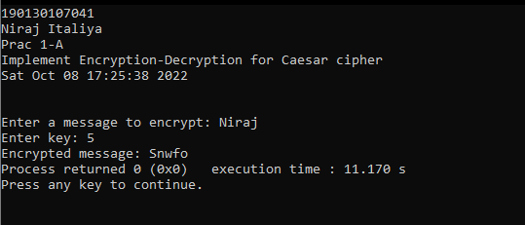



**Practical-1B: Implement encryption and decryption of brute force attack on Caesar cipher.**

**Code:**

#include<iostream>

#include<time.h>

using namespace std;

//function to encrypt the plain text

string encrypt(string x,int n)

{

string cipher="";

/* only caps and small caps alphabet would be considered for encryption other symbols would remain as it is.

*/

for(int i=0;i<x.length();i++)

{

if(isupper(x[i]))

cipher += (x[i] + n - 65)%26 + 65;

/* here x[i] would be ASCII value of corresponding alphabet */

else if(islower(x[i]))

cipher += (x[i] + n - 97)%26 + 97;

else

cipher += x[i];

/* other symbols other than alphabets would remain as it is. */

}

return cipher;

}

//function to decrypt the cipher text using brute force attack

void decrypt(string x)

{

string text;

for(int n=0;n<26;n++)

{

text = "";

for(int i=0;i<x.length();i++)

{

if(isupper(x[i]))

{

if((x[i] - n - 65)<0)

text += 91 + (x[i] - n - 65);

else

text += (x[i] - n - 65)%26 + 65;

}

else if(islower(x[i]))

{

if((x[i] - n - 97) < 0)

text += 123 + (x[i] - n - 97);

else

text += (x[i] - n - 97)%26 + 97;

}

else

text += x[i];

}

cout << "plain text for key " << n << " :- " << text << endl;

}

}

int main()

{

int key;

string text;

time_t t; // not a primitive datatype

time(&t);

cout << "190130107041\n";

cout << "Niraj Italiya\n";

cout << "1-B\n";

cout << "Implement encryption and decryption of brute force attack on Caesar cipher\n";

cout << ("%s\n\n", ctime(&t));

cout << "\nenter text:- ";

getline(cin,text);

cout << "enter key:- ";

cin >> key;

string cipher = encrypt(text,key);

cout << "cipher text :- " << cipher << endl << endl;

decrypt(cipher);

}

**Program Execution Snapshot :**

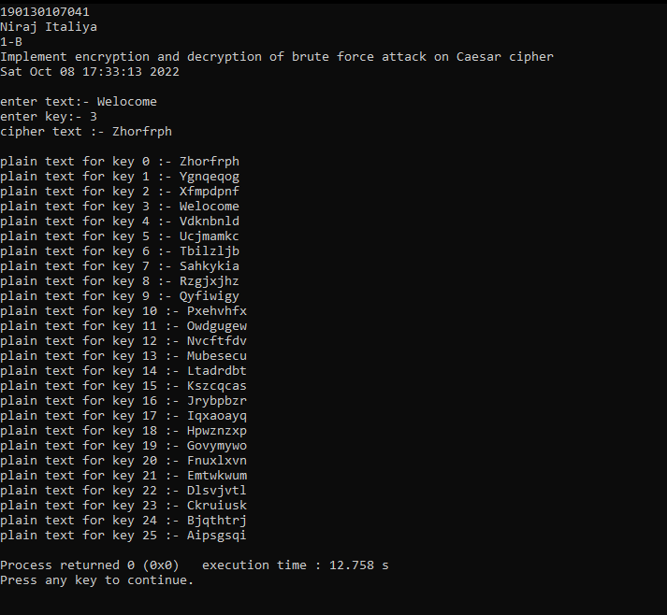

**Practical-2: Implement Rail-fence cipher encryption-decryption.**

**Code :**

#include<stdio.h>

#include<string.h>

#include<time.h>

void encryptMsg(char msg[], int key)

{

int msgLen = strlen(msg), i, j, k = -1, row = 0, col = 0;

char railMatrix[key][msgLen];

for(i = 0; i < key; ++i)

for(j = 0; j < msgLen; ++j)

railMatrix[i][j] = '\n';

for(i = 0; i < msgLen; ++i)

{

railMatrix[row][col++] = msg[i];

if(row == 0 || row == key-1)

k= k * (-1);

row = row + k;

}

printf("\nEncrypted Message: ");

for(i = 0; i < key; ++i)

for(j = 0; j < msgLen; ++j)

if(railMatrix[i][j] != '\n')

printf("%c", railMatrix[i][j]);

}

void decryptMsg(char enMsg[], int key)

{

int msgLen = strlen(enMsg), i, j, k = -1, row = 0, col = 0, m = 0;

char railMatrix[key][msgLen];

for(i = 0; i < key; ++i)

for(j = 0; j < msgLen; ++j)

railMatrix[i][j] = '\n';

for(i = 0; i < msgLen; ++i)

{

railMatrix[row][col++] = '*';

if(row == 0 || row == key-1)

k= k * (-1);

row = row + k;

}

for(i = 0; i < key; ++i)

for(j = 0; j < msgLen; ++j)

if(railMatrix[i][j] == '*')

railMatrix[i][j] = enMsg[m++];

row = col = 0;

k = -1;

printf("\nDecrypted Message: ");

for(i = 0; i < msgLen; ++i){

printf("%c", railMatrix[row][col++]);

if(row == 0 || row == key-1)

k= k * (-1);

row = row + k;

}

}

// Driver code

int main()

{

char msg[] = "Good Morning";

char enMsg[] = "G nodMrigoon";

int key = 3;

time_t t; // not a primitive datatype

time(&t);

printf("190130107041\n");

printf("Niraj Italiya\n");

printf("Prac 2\n");

printf("Implement Encryption-Decryption for Rail-fence cipher\n");

printf("%s\n\n", ctime(&t));

printf("Original Message: %s", msg);

encryptMsg(msg, key);

decryptMsg(enMsg, key);

return 0;

}

**Program Execution Snapshot** :

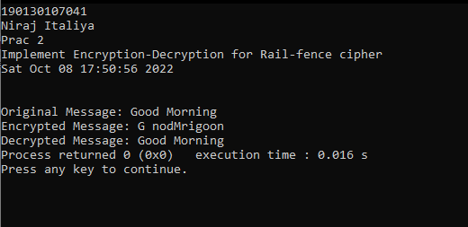

**Practical-3: Implement Playfair cipher encryption-decryption.**

**Code:**

#include <stdio.h>

#include <stdlib.h>

#include <string.h>

#include <time.h>

#define SIZE 30

// Function to convert the string to lowercase

void toLowerCase(char plain[], int ps)

{

int i;

for (i = 0; i < ps; i++)

{

if (plain[i] > 64 && plain[i] < 91)

plain[i] += 32;

}

}

// Function to remove all spaces in a string

int removeSpaces(char* plain, int ps){

int i, count = 0;

for (i = 0; i < ps; i++)

if (plain[i] != ' ')

plain[count++] = plain[i];

plain[count] = '\0';

return count;

}

// Function to generate the 5x5 key square

void generateKeyTable(char key[], int ks, char keyT[5][5]){

int i, j, k, flag = 0, *dicty;

// a 26 character hashmap

// to store count of the alphabet

dicty = (int*)calloc(26, sizeof(int));

for (i = 0; i < ks; i++)

{

if (key[i] != 'j')

dicty[key[i] - 97] = 2;

}

dicty['j' - 97] = 1;

i = 0;

j = 0;

for (k = 0; k < ks; k++)

{

if (dicty[key[k] - 97] == 2)

{

dicty[key[k] - 97] -= 1;

keyT[i][j] = key[k];

j++;

if (j == 5) {

i++;

j = 0;

}

}

}

for (k = 0; k < 26; k++)

{

if (dicty[k] == 0) {

keyT[i][j] = (char)(k + 97);

j++;

if (j == 5) {

i++;

j = 0;

}

}

}

}

// Function to search for the characters of a digraph

// in the key square and return their position

void search(char keyT[5][5], char a, char b, int arr[])

{

int i, j;

if (a == 'j')

a = 'i';

else if (b == 'j')

b = 'i';

for (i = 0; i < 5; i++) {

for (j = 0; j < 5; j++)

{

if (keyT[i][j] == a) {

arr[0] = i;

arr[1] = j;

}

else if (keyT[i][j] == b)

{

arr[2] = i;

arr[3] = j;

}

}

}

}

// Function to find the modulus with 5

int mod5(int a)

{

return (a % 5);

}

// Function to make the plain text length to be even

int prepare(char str[], int ptrs)

{

if (ptrs % 2 != 0) {

str[ptrs++] = 'z';

str[ptrs] = '\0';

}

return ptrs;

}

// Function for performing the encryption

void encrypt(char str[], char keyT[5][5], int ps)

{

int i, a[4];

for (i = 0; i < ps; i += 2)

{

search(keyT, str[i], str[i + 1], a);

if (a[0] == a[2])

{

str[i] = keyT[a[0]][mod5(a[1] + 1)];

str[i + 1] = keyT[a[0]][mod5(a[3] + 1)];

}

else if (a[1] == a[3]) {

str[i] = keyT[mod5(a[0] + 1)][a[1]];

str[i + 1] = keyT[mod5(a[2] + 1)][a[1]];

}

else {

str[i] = keyT[a[0]][a[3]];

str[i + 1] = keyT[a[2]][a[1]];

}

}

}

// Function to encrypt using Playfair Cipher

void encryptByPlayfairCipher(char str[], char key[])

{

char ps, ks, keyT[5][5];

// Key

ks = strlen(key);

ks = removeSpaces(key, ks);

toLowerCase(key, ks);

// Plaintext

ps = strlen(str);

toLowerCase(str, ps);

ps = removeSpaces(str, ps);

ps = prepare(str, ps);

generateKeyTable(key, ks, keyT);

encrypt(str, keyT, ps);

}

// Driver code

int main()

{

char str[SIZE], key[SIZE];

// Key to be encrypted

strcpy(key, "secret");

time_t t; // not a primitive datatype

time(&t);

printf("190130107041\n");

printf("Niraj Italiya\n");

printf("Prac 3\n");

printf("Implement Playfair cipher encryption decryption\n");

printf("%s\n\n", ctime(&t));

printf("Key text: %s\n", key);

// Plaintext to be encrypted

strcpy(str, "world");

printf("Plain text: %s\n", str);

// encrypt using Playfair Cipher

encryptByPlayfairCipher(str, key);

printf("Cipher text: %s\n", str);

return 0;

}

**Program Execution Snapshot:**

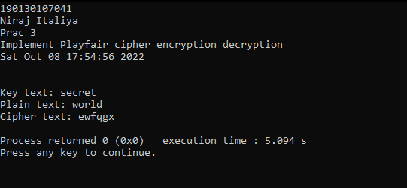

**Practical-4: Implement key generation of DES..**

**OR**

**Practical-5: Implement DES (Data Encryption Standard).**

**Code:**

def hex2bin(s):

mp = {'0': "0000",

'1': "0001",

'2': "0010",

'3': "0011",

'4': "0100",

'5': "0101",

'6': "0110",

'7': "0111",

'8': "1000",

'9': "1001",

'A': "1010",

'B': "1011",

'C': "1100",

'D': "1101",

'E': "1110",

'F': "1111"}

bin = ""

for i in range(len(s)):

bin = bin + mp[s[i]]

return bin

# Binary to hexadecimal conversion

def bin2hex(s):

mp = {"0000": '0',

"0001": '1',

"0010": '2',

"0011": '3',

"0100": '4',

"0101": '5',

"0110": '6',

"0111": '7',

"1000": '8',

"1001": '9',

"1010": 'A',

"1011": 'B',

"1100": 'C',

"1101": 'D',

"1110": 'E',

"1111": 'F'}

hex = ""

for i in range(0, len(s), 4):

ch = ""

ch = ch + s[i]

ch = ch + s[i + 1]

ch = ch + s[i + 2]

ch = ch + s[i + 3]

hex = hex + mp[ch]

return hex

def bin2dec(binary):

binary1 = binary

decimal, i, n = 0, 0, 0

while(binary != 0):

dec = binary % 10

decimal = decimal + dec * pow(2, i)

binary = binary//10

i += 1

return decimal

def dec2bin(num):

res = bin(num).replace("0b", "")

if(len(res) % 4 != 0):

div = len(res) / 4

div = int(div)

counter = (4 * (div + 1)) - len(res)

for i in range(0, counter):

res = '0' + res

return res

def permute(k, arr, n):

permutation = ""

for i in range(0, n):

permutation = permutation + k[arr[i] - 1]

return permutation

def shift_left(k, nth_shifts):

s = ""

for i in range(nth_shifts):

for j in range(1, len(k)):

s = s + k[j]

s = s + k[0]

k = s

s = ""

return k

def xor(a, b):

ans = ""

for i in range(len(a)):

if a[i] == b[i]:

ans = ans + "0"

else:

ans = ans + "1"

return ans

initial_perm = [58, 50, 42, 34, 26, 18, 10, 2,

60, 52, 44, 36, 28, 20, 12, 4,

62, 54, 46, 38, 30, 22, 14, 6,

64, 56, 48, 40, 32, 24, 16, 8,

57, 49, 41, 33, 25, 17, 9, 1,

59, 51, 43, 35, 27, 19, 11, 3,

61, 53, 45, 37, 29, 21, 13, 5,

63, 55, 47, 39, 31, 23, 15, 7]

# Expansion D-box Table

exp_d = [32, 1, 2, 3, 4, 5, 4, 5,

6, 7, 8, 9, 8, 9, 10, 11,

12, 13, 12, 13, 14, 15, 16, 17,

16, 17, 18, 19, 20, 21, 20, 21,

22, 23, 24, 25, 24, 25, 26, 27,

28, 29, 28, 29, 30, 31, 32, 1]

# Straight Permutation Table

per = [16, 7, 20, 21,

29, 12, 28, 17,

1, 15, 23, 26,

5, 18, 31, 10,

2, 8, 24, 14,

32, 27, 3, 9,

19, 13, 30, 6,

22, 11, 4, 25]

# S-box Table

sbox = [[[14, 4, 13, 1, 2, 15, 11, 8, 3, 10, 6, 12, 5, 9, 0, 7],

[0, 15, 7, 4, 14, 2, 13, 1, 10, 6, 12, 11, 9, 5, 3, 8],

[4, 1, 14, 8, 13, 6, 2, 11, 15, 12, 9, 7, 3, 10, 5, 0],

[15, 12, 8, 2, 4, 9, 1, 7, 5, 11, 3, 14, 10, 0, 6, 13]],

[[15, 1, 8, 14, 6, 11, 3, 4, 9, 7, 2, 13, 12, 0, 5, 10],

[3, 13, 4, 7, 15, 2, 8, 14, 12, 0, 1, 10, 6, 9, 11, 5],

[0, 14, 7, 11, 10, 4, 13, 1, 5, 8, 12, 6, 9, 3, 2, 15],

[13, 8, 10, 1, 3, 15, 4, 2, 11, 6, 7, 12, 0, 5, 14, 9]],

[[10, 0, 9, 14, 6, 3, 15, 5, 1, 13, 12, 7, 11, 4, 2, 8],

[13, 7, 0, 9, 3, 4, 6, 10, 2, 8, 5, 14, 12, 11, 15, 1],

[13, 6, 4, 9, 8, 15, 3, 0, 11, 1, 2, 12, 5, 10, 14, 7],

[1, 10, 13, 0, 6, 9, 8, 7, 4, 15, 14, 3, 11, 5, 2, 12]],

[[7, 13, 14, 3, 0, 6, 9, 10, 1, 2, 8, 5, 11, 12, 4, 15],

[13, 8, 11, 5, 6, 15, 0, 3, 4, 7, 2, 12, 1, 10, 14, 9],

[10, 6, 9, 0, 12, 11, 7, 13, 15, 1, 3, 14, 5, 2, 8, 4],

[3, 15, 0, 6, 10, 1, 13, 8, 9, 4, 5, 11, 12, 7, 2, 14]],

[[2, 12, 4, 1, 7, 10, 11, 6, 8, 5, 3, 15, 13, 0, 14, 9],

[14, 11, 2, 12, 4, 7, 13, 1, 5, 0, 15, 10, 3, 9, 8, 6],

[4, 2, 1, 11, 10, 13, 7, 8, 15, 9, 12, 5, 6, 3, 0, 14],

[11, 8, 12, 7, 1, 14, 2, 13, 6, 15, 0, 9, 10, 4, 5, 3]],

[[12, 1, 10, 15, 9, 2, 6, 8, 0, 13, 3, 4, 14, 7, 5, 11],

[10, 15, 4, 2, 7, 12, 9, 5, 6, 1, 13, 14, 0, 11, 3, 8],

[9, 14, 15, 5, 2, 8, 12, 3, 7, 0, 4, 10, 1, 13, 11, 6],

[4, 3, 2, 12, 9, 5, 15, 10, 11, 14, 1, 7, 6, 0, 8, 13]],

[[4, 11, 2, 14, 15, 0, 8, 13, 3, 12, 9, 7, 5, 10, 6, 1],

[13, 0, 11, 7, 4, 9, 1, 10, 14, 3, 5, 12, 2, 15, 8, 6],

[1, 4, 11, 13, 12, 3, 7, 14, 10, 15, 6, 8, 0, 5, 9, 2],

[6, 11, 13, 8, 1, 4, 10, 7, 9, 5, 0, 15, 14, 2, 3, 12]],

[[13, 2, 8, 4, 6, 15, 11, 1, 10, 9, 3, 14, 5, 0, 12, 7],

[1, 15, 13, 8, 10, 3, 7, 4, 12, 5, 6, 11, 0, 14, 9, 2],

[7, 11, 4, 1, 9, 12, 14, 2, 0, 6, 10, 13, 15, 3, 5, 8],

[2, 1, 14, 7, 4, 10, 8, 13, 15, 12, 9, 0, 3, 5, 6, 11]]]

# Final Permutation Table

final_perm = [40, 8, 48, 16, 56, 24, 64, 32,

39, 7, 47, 15, 55, 23, 63, 31,

38, 6, 46, 14, 54, 22, 62, 30,

37, 5, 45, 13, 53, 21, 61, 29,

36, 4, 44, 12, 52, 20, 60, 28,

35, 3, 43, 11, 51, 19, 59, 27,

34, 2, 42, 10, 50, 18, 58, 26,

33, 1, 41, 9, 49, 17, 57, 25]

def encrypt(pt, rkb, rk):

pt = hex2bin(pt)

# Initial Permutation

pt = permute(pt, initial_perm, 64)

print("After initial permutation", bin2hex(pt))

# Splitting

left = pt[0:32]

right = pt[32:64]

for i in range(0, 16):

# Expansion D-box: Expanding the 32 bits data into 48 bits

right_expanded = permute(right, exp_d, 48)

# XOR RoundKey[i] and right_expanded

xor_x = xor(right_expanded, rkb[i])

# S-boxex: substituting the value from s-box table by calculating row and column

sbox_str = ""

for j in range(0, 8):

row = bin2dec(int(xor_x[j * 6] + xor_x[j * 6 + 5]))

col = bin2dec(

int(xor_x[j * 6 + 1] + xor_x[j * 6 + 2] + xor_x[j * 6 + 3] + xor_x[j * 6 + 4]))

val = sbox[j][row][col]

sbox_str = sbox_str + dec2bin(val)

# Straight D-box: After substituting rearranging the bits

sbox_str = permute(sbox_str, per, 32)

# XOR left and sbox_str

result = xor(left, sbox_str)

left = result

if(i != 15):

left, right = right, left

print("Round ", i + 1, " ", bin2hex(left),

" ", bin2hex(right), " ", rk[i])

combine = left + right

cipher_text = permute(combine, final_perm, 64)

return cipher_text

pt = "123456ABCD132536"

key = "AABB09182736CCDD"

key = hex2bin(key)

keyp = [57, 49, 41, 33, 25, 17, 9,

1, 58, 50, 42, 34, 26, 18,

10, 2, 59, 51, 43, 35, 27,

19, 11, 3, 60, 52, 44, 36,

63, 55, 47, 39, 31, 23, 15,

7, 62, 54, 46, 38, 30, 22,

14, 6, 61, 53, 45, 37, 29,

21, 13, 5, 28, 20, 12, 4]

key = permute(key, keyp, 56)

shift_table = [1, 1, 2, 2,

2, 2, 2, 2,

1, 2, 2, 2,

2, 2, 2, 1]

key_comp = [14, 17, 11, 24, 1, 5,

3, 28, 15, 6, 21, 10,

23, 19, 12, 4, 26, 8,

16, 7, 27, 20, 13, 2,

41, 52, 31, 37, 47, 55,

30, 40, 51, 45, 33, 48,

44, 49, 39, 56, 34, 53,

46, 42, 50, 36, 29, 32]

left = key[0:28] # rkb for RoundKeys in binary

right = key[28:56] # rk for RoundKeys in hexadecimal

rkb = []

rk = []

for i in range(0, 16):

left = shift_left(left, shift_table[i])

right = shift_left(right, shift_table[i])

combine_str = left + right

round_key = permute(combine_str, key_comp, 48)

rkb.append(round_key)

rk.append(bin2hex(round_key))

print("Name :- niraj italiya")

print ("190130107041 CE -A2")

print("Encryption")

cipher_text = bin2hex(encrypt(pt, rkb, rk))

print("Cipher Text : ", cipher_text)

print("Decryption")

rkb_rev = rkb[::-1]

rk_rev = rk[::-1]

text = bin2hex(encrypt(cipher_text, rkb_rev, rk_rev))

print("Plain Text : ", text)

**output:-**

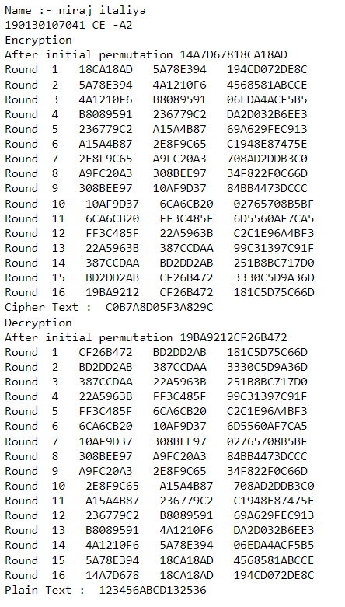

**Practical-6 : Implement key generation of AES.**

**Code:**

package Pra_06;

// package I;

import java.nio.charset.StandardCharsets;

import java.security.spec.KeySpec;

import java.util.Base64;

import java.util.Date;

import javax.crypto.Cipher;

import javax.crypto.SecretKey;

import javax.crypto.SecretKeyFactory;

import javax.crypto.spec.IvParameterSpec;

import javax.crypto.spec.PBEKeySpec;

import javax.crypto.spec.SecretKeySpec;

class AES {

// Class private variables

private static final String SECRET_KEY = "my_super_secret_key_ho_ho_ho";

private static final String SALT = "ssshhhhhhhhhhh!!!!";

// This method use to encrypt to string

public static String encrypt(String strToEncrypt)

{

try {

// Create default byte array

byte[] iv = { 0, 0, 0, 0, 0, 0, 0, 0, 0, 0, 0, 0, 0, 0, 0, 0 };

IvParameterSpec ivspec = new IvParameterSpec(iv);

// Create SecretKeyFactory object

SecretKeyFactory factory = SecretKeyFactory.getInstance("PBKDF2WithHmacSHA256");

// Create KeySpec object and assign with

// constructor

KeySpec spec = new PBEKeySpec(SECRET_KEY.toCharArray(), SALT.getBytes(), 65536, 256);

SecretKey tmp = factory.generateSecret(spec);

SecretKeySpec secretKey = new SecretKeySpec(

tmp.getEncoded(), "AES");

Cipher cipher = Cipher.getInstance("AES/CBC/PKCS5Padding");

cipher.init(Cipher.ENCRYPT_MODE, secretKey,ivspec);

// Return encrypted string

return Base64.getEncoder().encodeToString(cipher.doFinal(strToEncrypt.getBytes(StandardCharsets.UTF_8)));

}

catch (Exception e) {

System.out.println("Error while encrypting: " + e.toString());

}

return null;

}

// This method use to decrypt to string

public static String decrypt(String strToDecrypt)

{

try {

// Default byte array

byte[] iv = { 0, 0, 0, 0, 0, 0, 0, 0, 0, 0, 0, 0, 0, 0, 0, 0 };

// Create IvParameterSpec object and assign with

// constructor

IvParameterSpec ivspec = new IvParameterSpec(iv);

// Create SecretKeyFactory Object

SecretKeyFactory factory = SecretKeyFactory.getInstance("PBKDF2WithHmacSHA256");

// Create KeySpec object and assign with

// constructor

KeySpec spec = new PBEKeySpec( SECRET_KEY.toCharArray(), SALT.getBytes(), 65536, 256);

SecretKey tmp = factory.generateSecret(spec);

SecretKeySpec secretKey = new SecretKeySpec( tmp.getEncoded(), "AES");

Cipher cipher = Cipher.getInstance("AES/CBC/PKCS5PADDING");

cipher.init(Cipher.DECRYPT_MODE, secretKey, ivspec);

// Return decrypted string

return new String(cipher.doFinal(Base64.getDecoder().decode(strToDecrypt)));

}

catch (Exception e) {

System.out.println("Error while decrypting: " + e.toString());

}

return null;

}

}

// driver code

class Pra_06 {

public static void main(String[] args)

{

System.out.println("190130107041");

System.out.println("Niraj Italiya");

System.out.println("Practical : 06");

System.out.println("Implement key generation of AES.");

Date date = new Date();

System.out.println(date.toString());

// Create String variables

String originalString = "Secret";

// Call encryption method

String encryptedString = AES.encrypt(originalString);

// Call decryption method

String decryptedString = AES.decrypt(encryptedString);

// Print all strings

System.out.println(originalString);

System.out.println(encryptedString);

System.out.println(decryptedString);

}

}

**Program Execution Snapshot :**

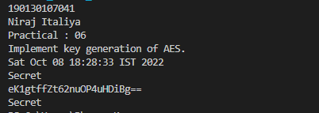

**Practical-7 :**

**Code:**

/* This program calculates the Key for two persons

using the Diffie-Hellman Key exchange algorithm */

#include<stdio.h>

#include<math.h>

#include<time.h>

// Power function to return value of a ^ b mod P

long long int power(long long int a, long long int b, long long int P)

{

if (b == 1)

return a;

else

return (((long long int)pow(a, b)) % P);

// int r;

// int y=1;

// while(b>0){

// r=b%2;

// if (r==1){

// y=(y*a)%P;

// }

// a=a*a%P;

// b=b/2;

// }

// return y;

}

//Driver program

int main()

{

long long int P, G, x, a, y, b, ka, kb;

time_t t; // not a primitive datatype

time(&t);

printf("190130107041\n");

printf("Niraj Italiya\n");

printf("Prac 7\n");

printf("Implement Diffi-Hellmen Key exchange Method.\n");

printf("%s\n", ctime(&t));

// Both the persons will be agreed upon the

// public keys G and P

P = 23; // A prime number P is taken

printf("\nThe value of P : %lld\n", P);

G = 5; // A primitve root for P, G is taken

// G=9;

printf("The value of G : %lld\n\n", G);

// Alice will choose the private key a

a = 6; // a is the chosen private key

// a=4;

printf("The private key a for Alice : %lld\n", a);

x = power(G, a, P); // gets the generated key

// Bob will choose the private key b

b = 15; // b is the chosen private key

// b=3;

printf("The private key b for Bob : %lld\n\n", b);

y = power(G, b, P); // gets the generated key

printf("x : %lld\n", x);

printf("y : %lld\n", y);

// Generating the secret key after the exchange of keys

ka = power(y, a, P); // Secret key for Alice

printf("Secret key for the Alice is : %lld\n", ka);

kb = power(x, b, P); // Secret key for Bob

printf("Secret Key for the Bob is : %lld\n", kb);

return 0;

}

**Program Execution Snapshot :**

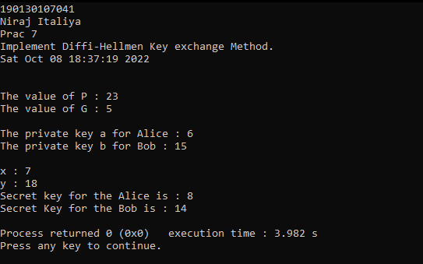

**Practical-8: Implement RSA key setup and encryption-decryption algorithm.**

**Code:**

#include<stdio.h>

#include<math.h>

#include<time.h>

//to find gcd

int gcd(int a, int h)

{

int temp;

while(1)

{

temp = a%h;

if(temp==0)

return h;

a = h;

h = temp;

}

}

int main()

{

time_t t; // not a primitive datatype

time(&t);

printf("190130107041 \n");

printf("Niraj Italiya\n");

printf("Prac 8\n");

printf("mplement RSA key setup and encryption-decryption algorithm.\n");

printf("%s\n", ctime(&t));

//2 random prime numbers

double p = 3;

double q = 7;

double n=p*q;

double count;

double totient = (p-1)*(q-1);

//public key

//e stands for encrypt

double e=2;

//for checking co-prime which satisfies e>1

while(e<totient){

count = gcd(e,totient);

if(count==1)

break;

else

e++;

}

//private key

//d stands for decrypt

double d;

//k can be any arbitrary value

double k = 2;

//choosing d such that it satisfies d*e = 1 + k * totient

d = (1 + (k*totient))/e;

double msg = 12;

double c = pow(msg,e);

double m = pow(c,d);

c=fmod(c,n);

m=fmod(m,n);

printf("Message data = %lf",msg);

printf("\np = %lf",p);

printf("\nq = %lf",q);

printf("\nn = pq = %lf",n);

printf("\ntotient = %lf",totient);

printf("\ne = %lf",e);

printf("\nd = %lf",d);

printf("\nEncrypted data = %lf",c);

printf("\nOriginal Message Sent = %lf",m);

return 0;

}

**Program Execution Snapshot:**

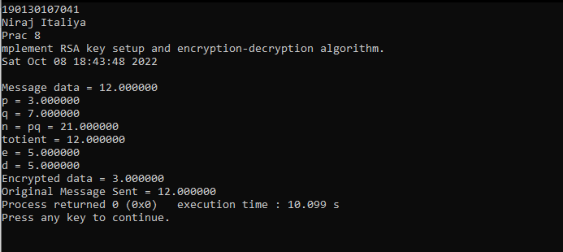

**Practical-9: Write a program to generate SHA-1 hash.**

**Code:**

package Pra_09;

import java.math.BigInteger;

import java.security.MessageDigest;

import java.security.NoSuchAlgorithmException;

import java.util.*;

public class Pra9 {

public static String encryptThisString(String input)

{

try {

// getInstance() method is called with algorithm SHA-1

MessageDigest md = MessageDigest.getInstance("SHA-1");

// digest() method is called

// to calculate message digest of the input string

// returned as array of byte

byte[] messageDigest = md.digest(input.getBytes());

// Convert byte array into signum representation

BigInteger no = new BigInteger(1, messageDigest);

// Convert message digest into hex value

String hashtext = no.toString(16);

// Add preceding 0s to make it 32 bit

while (hashtext.length() < 32) {

hashtext = "0" + hashtext;

}

// return the HashText

return hashtext;

}

// For specifying wrong message digest algorithms

catch (NoSuchAlgorithmException e) {

throw new RuntimeException(e);

}

}

// Driver code

public static void main(String args[]) throws NoSuchAlgorithmException

{

System.out.println("190130107041");

System.out.println("Niraj Italiya");

System.out.println("Prac 9");

System.out.println("Write a program to generate SHA-1 hash.");

Date date = new Date();

System.out.println(date.toString());

System.out.println("\n");

System.out.println("HashCode Generated by SHA-1 for: \n");

String s1 = "Secret";

System.out.println("\n" + s1 + " : " + encryptThisString(s1));

String s2 = "NiceEdit";

System.out.println("\n" + s2 + " : " + encryptThisString(s2));

}

}

**Program Execution Snapshot**:

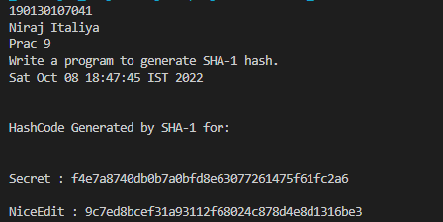

**Practical-10: Implement a digital signature algorithm.**

**Code:**

package Pra_10;

package Pra_10;

import java.security.KeyPair;

import java.security.KeyPairGenerator;

import java.security.PrivateKey;

import java.security.Signature;

import java.util.*;

public class Pra_10 {

public static void main(String args[]) throws Exception {

//Accepting text from user

System.out.println("190130107041");

System.out.println("Niraj Italiya");

System.out.println("Prac 10");

System.out.println("Implement a digital signature algorithm.");

Date date = new Date();

System.out.println(date.toString());

System.out.println("\n Secret Message");

String msg = "Secret Message";

//Creating KeyPair generator object

KeyPairGenerator keyPairGen = KeyPairGenerator.getInstance("DSA");

//Initializing the key pair generator

keyPairGen.initialize(2048);

//Generate the pair of keys

KeyPair pair = keyPairGen.generateKeyPair();

//Getting the private key from the key pair

PrivateKey privKey = pair.getPrivate();

//Creating a Signature object

Signature sign = Signature.getInstance("SHA256withDSA");

//Initialize the signature

sign.initSign(privKey);

byte[] bytes = msg.getBytes();

//Adding data to the signature

sign.update(bytes);

//Calculating the signature

byte[] signature = sign.sign();

//Printing the signature

System.out.println("Digital signature for given text:\n "+new String(signature, "UTF8"));

} }

**Program Execution Snapshot**:

